BNF notation
<non terminal tag>: define a rule name that is non terminal on conway notion that's the cartouche (rectangle).
::= : this define the rule.
|: that's or operator.
{}: cardinality operator from 0 to n.
[]: cardinality operator from 0 to 1.
(): group expression no impact can define priority.
'' or “”: defines terminal on conway notation that's the circle or oval.

whole_query definition
BNF definition
<whole_query>::=<put_column_names>
<put_online_tables> <put_online_query>
Synopsis:
Defines the query structure on the data base.

Conway diagram:
put column_names definition
BNF definition
<put_column_names>::='SELECT' <one_or_more_spaces>
<list_of_column_names>
Synopsis:
Defines the structure that will output the column value list according to the given query.

Conway diagram
list_of_columns definition
BNF definition
<list_of_column_names>::=
<column_name>
<zero_or_more_spaces>
{
',' <zero_or_more_spaces> <column_name>
<zero_or_more_spaces>
}
|
'*'
Synopsis:
Defines a column name list. The cardinality of the list can be one or as many as you need. Each element of the list is separated with a comma. To specify the all the column name we need the character '*'.

Conway diagram

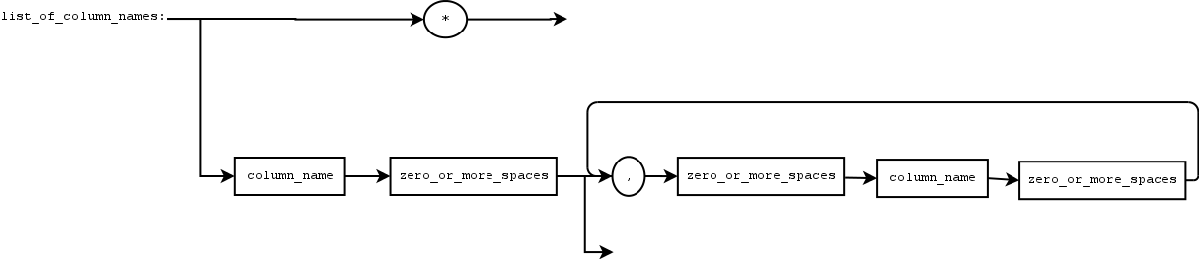
put_online_tables definition
BNF definition:
<put_online_tables>::='USE_TABLES' <one_or_more_spaces>
<table_list>

Synopsis:
Declares all the tables to use in order to works on columns. Watch out each columns names must be unique. Object is not yet supported as prototyping.

Conway diagram:
table_list definition
BNF definition:
<table_list>::=<table_name> {<zero_or_more_spaces> ','
<zero_or_more_spaces> <table_name>}
Synopsis:
We define list of tables to be used in order to put on line column names to link with queries.

Conway diagram:
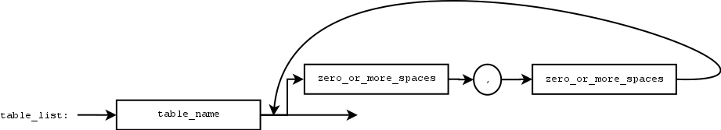

table_name definition
BNF definition:
<table_name>::=<upper_case_character> {< upper_case_character>|<lower_case_character>|<number_character>|'_'}

Synopsis:
We define a list of tables in order to link with queries. For the time being column names have to be unique between each tables.

Conway diagram:
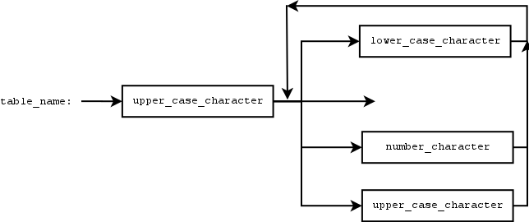

put_online_query definition
BNF definition:
<put_online_query>::='WHERE' <one_or_more_spaces> <complex_query>
Synopsis:
We define a special area. This area in the query is dedicated to queries themselves.

Conway diagram:
Examples:
We assume that in DB the columns COLUMN_INT_P COLUMN_STR1 COLUMN_INT_O are defined respectively otherwise an error is raised hence in this paragraph it is out of subject.

Note: in the future we can define a kinda shell to do that.

Bold faces mean that it is defined by default in the compiler (see belowin this frame)

example 1:
WHERE COLUMN_INT_P<=7 OR COLUMN_STR1 eq ”TOTO1oooo”

example 2:
WHERE COLUMN_INT_O <= 7 OR (COLUMN_STR1 eq ”TO1oooo” AND COLUMN_INT<=7 AND COLUMN_STR1 eq ”TOTO1oo”)

complex_query definition
BNF definition:
<complex_query>::=
<one_line_pattern>
|
(
<zero_or_more_spaces>
'('
<one_line_pattern>
')'
| # bug when ! is in first place
<zero_or_more_spaces> <unary_not> <one_or_more_spaces>
'('
<one_line_pattern>
')'
) <logical_operator> <one_or_more_spaces> <complex_query>
|
<zero_or_more_spaces>
'('
<one_line_pattern>
')'
|
<zero_or_more_spaces> <unary_not> <zero_or_more_spaces>
'('
<one_line_pattern>
')'
| <zero_or_more_spaces> <basic_query>
| <unary_not> <zero_or_more_spaces> <basic_query>

Synopsis:
Defines a complex query.

Conway diagram:
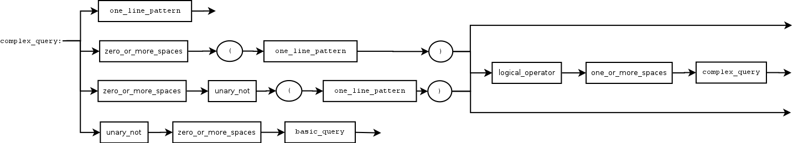
Examples:
We assume that in DB the columns COLUMN_INT_P COLUMN_STR1 COLUMN_INT_O are defined respectively otherwise an error is raised hence in this paragraph it is out of subject. We don't manage errors here.

- example 1:
COLUMN_INT_P<=7 OR COLUMN_STR1 eq ”TOTO1oooo”

- example 2:
COLUMN_INT_O <= 7 OR ( COLUMN_STR1 eq ”TO1oooo” AND COLUMN_INT<=7 AND COLUMN_STR1 eq ”TOTO1oo”)

one_line_pattern definition

BNF definition:
<one_line_pattern>::=<complex_query_other>
<complex_query>
<one_or_more_spaces>

Synopsis:
We define one line pattern.

Conway diagram:
complex_query_other definition
BNF definition:
<complex_query_other>::=<zero_or_more_spaces>
<basic_query> <one_or_more_spaces> <logical_operator> <one_or_more_spaces>

Synopsis:
Defines a complex a query starting with spaces or not followed by a query (column name operator value) followed by space(s) and a logical operator then one or more spaces.

Conway diagram:
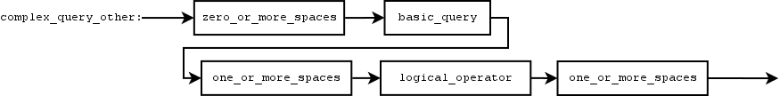
one_or_more_spaces definition
BNF definition:
<one_or_more_spaces>::=' ' {' '}

Synopsis:
Defines a string with at least one space.

Conway diagram:
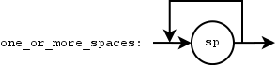
zero_or_more_spaces definition
BNF definition:
<zero_or_more_spaces>::={' '}

Synopsis:
Defines an empty string or a string with space(s).

Conway diagram:
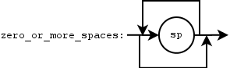
logical_operator definition
BNF definition:
<logical_operator>::=<positive_logical_operator>
|<negative_logical_operator>

Synopsis:
Defines the logical operators: positive or negative.

Conway diagram:

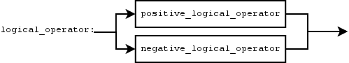

positive_logical_operator definition
BNF definition:
<positive_logical_operator>::=<and_operator>
|<nand_operator>
|<or_operator>
|<xor_operator>
Synopsis:
Defines the logical operators: AND, NAND, OR, XOR.

Conway diagram:
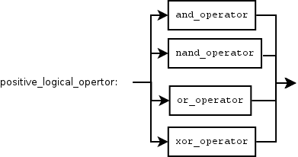
negative_logical_operator definition
BNF definition:
<negative_logical_operator>::=
<unary_not_operator>
<zero_or_more_spaces>
(
<and_operator>
|<nand_operator>
|<or_operator>
|<xor_operator>
)

Synopsis:
Defines the logical operators negative version.

Conway diagram:
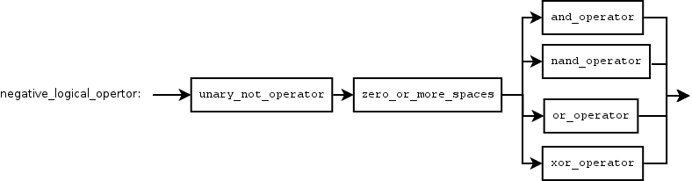
and_operator definition
BNF definition:
<and_operator>::= 'AND'

Synopsys:
Defines the AND logical operator.

Conway diagram:
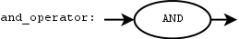
unary_not_operator definition
BNF definition:
<unary_not_operator>::='!'

Synopsys:
Defines the unary not operator.

Conway diagram:
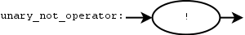
nand_operator definition
BNF definition:
<nand_operator>::='NAND'

Synopsys:
Defines the NAND logical operator.

Conway diagram:
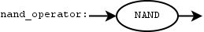
or_operator definition
BNF definition:
<or_operator>::='OR'

Synopsys:
Defines the OR logical operator.

Conway diagram:
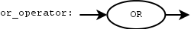

xor_operator definition
BNF definition:
<xor_operator>::='XOR'

Synopsys:
Defines XOR logical operator.

Conway diagram:

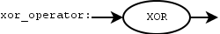
basic_query definition
BNF definition:
<basic_query>::=<column_name>
(
<zero_or_more_spaces>
<operators_of_comparison_for_number> <zero_or_more_spaces> <operand_syntax_values_number>
)
|
(
<one_or_more_spaces>
<operators_of_comparison_for_string> <one_or_more_spaces> <operand_syntax_values_string>
)

Synopsis:
Defines the basics of a query string that is a column name followed by spaces or not then an operator of comparison that suit strings followed by spaces or not and then a given value. For the numbers there are regular operators.

Conway diagram:
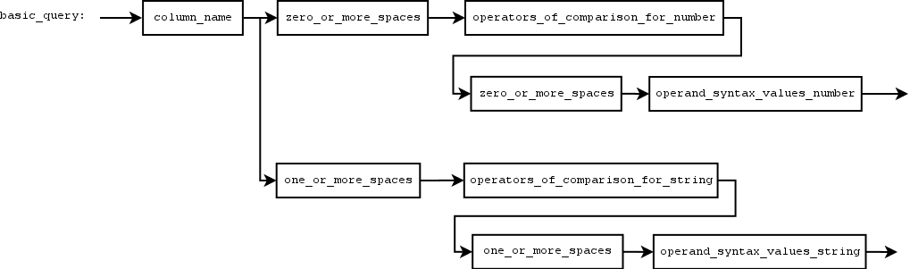
Example:

Watchout the model does not take care or make the difference between integers and string comparison need to check if it as to be this way. This should but do we need to introduce the notion of type? If so, what types?

Numbers:
COLUNM_INT==3
COLUNM_INT== 3
COLUNM_INT ==3
COLUMN_INT>=3
COLUMN_INT_O>3
COLUMN_INT_O<6
COLUMN_INT_P<=7

Character strings:
COLUMN_STR1 eq ”TOTO1oooo”
COLUMN_STR2 ne ”TO2TOoooo”
COLUMN_STR3 lt ”TO5TOoooo”
COLUMN_STR4 gt ”T11OTOoooo”
COLUMN_STR5 le ”T 3 OTOoooo”
COLUMN_STR_5 ge ”TOT8 Ooooo”

operand_syntax_values_number definition
BNF definition:
<operand_syntax_values_number>::=<number_value>

Synopsis:
We define an operand syntax values such as a value as a number.

Conway diagram:

operand_syntax_values_string definition
BNF definition:
<operand_syntax_values_string>::=
<quote> {<character_value_between_quote>} <quote>
|
<double_quote> {<character_value_between_double_quote>} <double_quote>

Synopsis:
We define an operand syntax values such as a set of a string that can be contained between double quote or a quote.

Conway diagram:
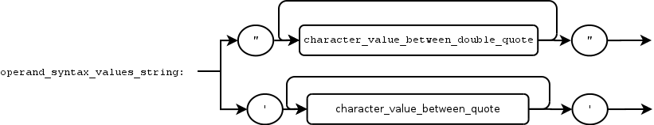
character_value_between_double_quote definition
BNF definition:
<character_value_between_double_quote>::=”\\”|”'”|”\””|
"”|"!"|"#"|"$"|"%"|"&"|"'"|"("|")"|"*"|"+"|","|"-"|"."|"/"|"0"|"1"|"2"|"3"|"4"|"5"|"6"|"7"|"8"|"9"|":"|";"|"<"|"="|">"|"?"|"@"|"A"|"B"|"C"|"D"|"E"|"F"|"G"|"H"|"I"|"J"|"K"|"L"|"M"|"N"|"O"|"P"|"Q"|"R"|"S"|"T"|"U"|"V"|"W"|"X"|"Y"|"Z"|"["|"]"|"^"|"_"|"`"|"a"|"b"|"c"|"d"|"e"|"f"|"g"|"h"|"i"|"j"|"k"|"l"|"m"|"n"|"o"|"p"|"q"|"r"|"s"|"t"|"u"|"v"|"w"|"x"|"y"|"z"|"{"|"|"|"}"|"~"

Synopsis:
We define the alphabet for a character value between double quote (ascii order in diagram below).

Conway diagram:
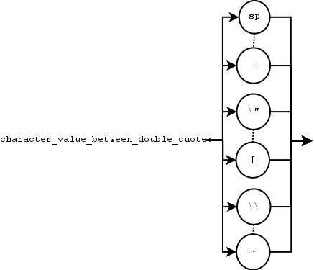
character_value_between_quote definition
BNF definition:
<character_value_between_quote>::='\\'|'\''|'”'
|' ' |'!'|'"'|'#'|'$'|'%'|'&'|'('|')'|'*'|'+'|','|'-'|'.'|'/'|'0'|'1'|'2'|'3'|'4'|'5'|'6'|'7'|'8'|'9'|':'|';'|'<'|'='|'>'|'?'|'@'|'A'|'B'|'C'|'D'|'E'|'F'|'G'|'H'|'I'|'J'|'K'|'L'|'M'|'N'|'O'|'P'|'Q'|'R'|'S'|'T'|'U'|'V'|'W'|'X'|'Y'|'Z'|'['|']'|'^'|'_'|'`'|'a'|'b'|'c'|'d'|'e'|'f'|'g'|'h'|'i'|'j'|'k'|'l'|'m'|'n'|'o'|'p'|'q'|'r'|'s'|'t'|'u'|'v'|'w'|'x'|'y'|'z'|'{'|'|'|'}'|'~'

Synopsis:
We define the alphabet for a character value between quote (ascii order in diagram below).

Conway diagram:
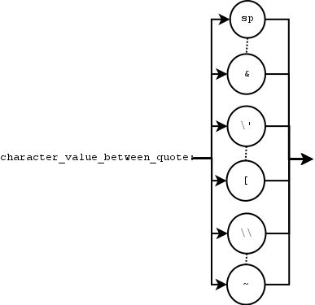

number_value definition
BNF definition:
<number_value>::=<number_real_value>
|<number_floating_value>

Synopsis:
We define a number as a set of several <digit_number>. The number_value is real.

Conway diagram:
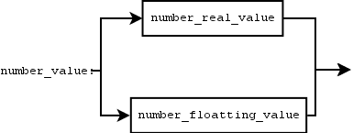
number_real_value definition
BNF definition:
<number_real_value>::={<number_digit>}

Synopsis:
We define a number as a set of several <digit_number>. The number_value is a real.

Conway diagram:
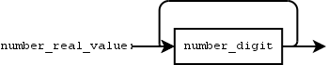
number_floating_value definition
BNF definition:
<number_floating_value>::={<number_digit>} '.' {<number_digit>}

Synopsis:
We define a number as a set of several <digit_number> followed by a '.' and then another set of <digit_number>. The number_value is floating.

Conway diagram:
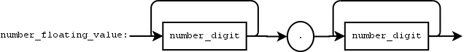
quote definition
BNF definition:
<quote>::=”'”

Synopsis:
That's the character quote.

Conway diagram:
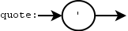
double_quote definition
BNF definition:
<double_quote>::='”'

Synopsis:
That's the character double quote.

Conway diagram:
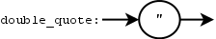
operator_of_comparison_number definition
BNF definition:
<operators_of_comparison_number>::=<operator_equal_to>
|<operator_not_equal_to>
|<operator_less_than>
|<operator_greater_than>
|<operator_less_than_or_equal_to>
|<operator_greater_than_or_equal_to>

Synopsis:
We define an operator of comparison for for a column name that old a number in the data base.

Conway diagram:
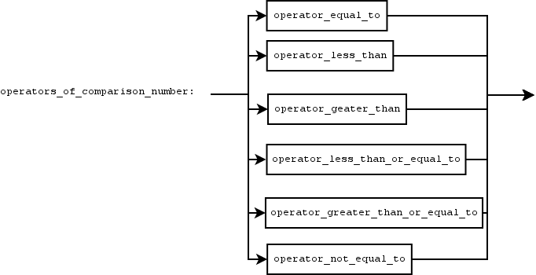
operator_equal_to definition

BNF definition:
<operator_equal_to>::='=='

Synopsis:
We define an operator of comparison equal to a specific value.

Conway diagram:
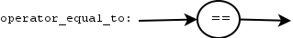
operator_not_equal_to definition

BNF definition:
<operator_not_equal_to>::='!='

Synopsis:
We define an operator of comparison not equal but it can be seen as different to a specific value.

Conway diagram:
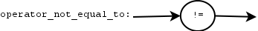
operator_less_than_to definition

BNF definition:
<operator_less_than_to>::='<'

Synopsis:
We define an operator of comparison less than a specific value.

Conway diagram:

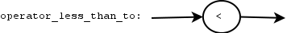
operator_greater_than definition

BNF definition:
<operator_greater_than>::='>'

Synopsis:
We define an operator of comparison greater than a specific value.

Conway diagram:
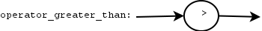

operator_less_than_or_equal_to definition

BNF definition:
<operator_less_than_or_equal_to>::='<='

Synopsis:
We define an operator of comparison less than equal to a specific value.

Conway diagram:
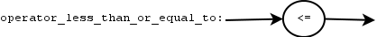
operator_greater_than_or_equal_to definition

BNF definition:
<operator_greater_than_or_equal_to>::='>='

Synopsis:
We define an operator of comparison greater than or equal to a specific value.

Conway diagram:
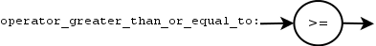

operators_of_comparison_for_string definition
BNF definition:
<operators_of_comparison_for_string>::=
<operator_equal_to_for_string>
|<operator_not_equal_to_for_string>
|<operator_greater_than_for_string>
|<operator_less_than_for_string>
|<operator_greater_than_or_equal_to_for_string>
|<operator_less_than_or_equal_to_for_string>

Synopsis:
We define a serie of operator of comparison to between two strings.

Conway diagram:
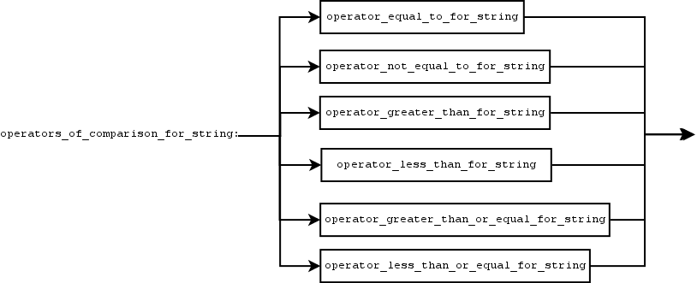
operator_equal_to_for_string definition
BNF definition:
<operator_equal_to_for_string>::='eq'

Synopsis:
We define an operator of comparison equal to between two strings.

Conway diagram:
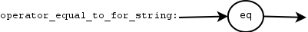
operator_not_equal_to_for_string definition
BNF definition:
<operator_not_equal_to_sor_string>::='ne'

Synopsis:
We define an operator of comparison not equal between two strings.

Conway diagram:
operator_less_than_for_string definition
BNF definition:
<operator_less_than_for_string>::='lt'

Synopsis:
We define an operator of comparison less than between two strings.

Conway diagram:
operator_greater_than_for_string definition
BNF definition:
<operator_greater_than_for_string>::='gt'

Synopsis:
We define an operator of comparison greater than between two strings.

Conway diagram:
operator_less_than_or_equal_to_for_string definition
BNF definition:
<operator_less_than_or_equal_to_for_string>::='le'

Synopsis:
We define an operator of comparison less than equal to between two strings.

Conway diagram:
operator_greater_than_or_equal_to_for_string definition
BNF definition:
<operator_greater_than_or_equal_to_for_string>::='ge'

Synopsis:
We define an operator of comparison greater than or equal to between two strings.

Conway diagram:
column_name definition

BNF definition:
<column_name>::=<lower_case_character> {<second_part_col_name>}

Synopsis:
We define a column name in the data base. The first letter is a ascii character (a-zA-Z). The second part can be one or more time. The column name must ha a length at least of two characters.

Conway diagram:
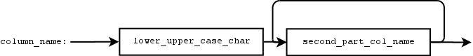

lower_and_upper_case_characters definition

BNF definition:
<lower_and_upper_case_characters>::=<lower_case_character>
|<upper_case_character>

Synopsis:
This defines only a character set of the ascii alphabet: lower and upper letter.

Conway diagram:
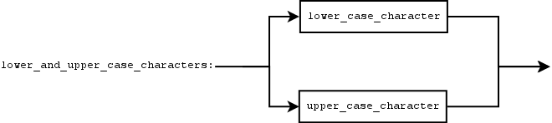
second_part_col_name definition

BNF definition:
<second_part_col_name>::=<number_character>
|<underline_character>
|<lower_and_upper_case_characaters>

Synopsis:
Defines a character set of the second part of a column name. The alphabet can be number as a character, underline character, or in the common alphabet as lower or upper ascii letter.

Conway diagram:
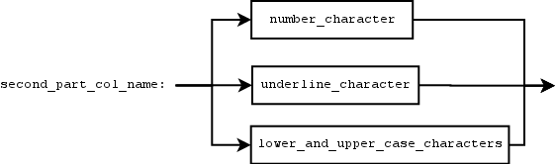
number_character definition

BNF definition:
<number_character>::='0'
|'1'
|'2'
|'3'
|'4'
|'5'
|'6'
|'7'
|'8'
|'9'

Synopsis:
Define an alphabet that is a set of character that can be a number.

Conway diagram:
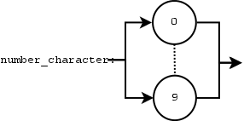
number_character definition

BNF definition:
<number_digit>::=0
|1
|2
|3
|4
|5
|6
|7
|8
|9

Synopsis:
Define an alphabet that is one digit number in the alphabet 0..9.

Conway diagram:
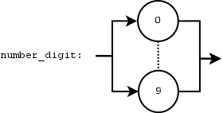
lower_case_character definition

BNF definition:
<lower_case_character>::='a'
|'b'
|'c'
|'d'
|'e'
|'f'
|'g'
|'h'
|'i'
|'j'
|'k'
|'l'
|'m'
|'n'
|'o'
|'p'
|'q'
|'r'
|'s'
|'t'
|'u'
|'v'
|'w'
|'x'
|'y'
|'z'

Conway diagram:
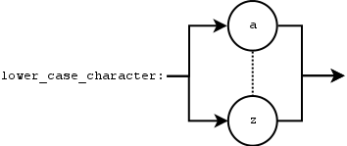
upper_case_character definition

Synopsis:
This is the alphabet but upper case definition

BNF definition:
<upper_case_character>::='A'
|'B'
|'C'
|'D'
|'E'
|'F'
|'G'
|'H'
|'I'
|'J'
|'K'
|'L'
|'M'
|'N'
|'O'
|'P'
|'Q'
|'R'
|'S'
|'T'
|'U'
|'V'
|'W'
|'X'
|'Y'
|'Z'

Conway diagram:

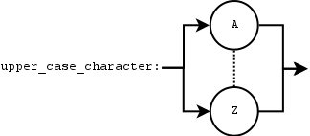

See <put_on_line_tables> synopsis remark regarding column names.

